***Abanob Evram***

***Assignmen4***



**[****Q1]**

**The design code:**

**The testbench code:**

**The do file code:**

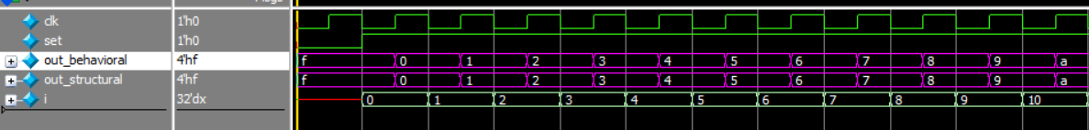

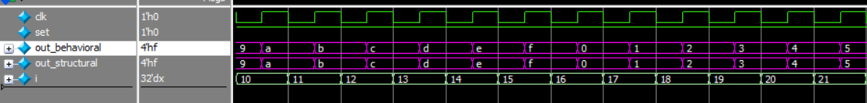

**[Q2]**

**The design code:**

**The testbench code:**

**The design code (first design):**

**The design code (second design):**

**The testbench code:**



**[Q4]**

**The design code (first design):**

**The design code (second design):**

**The testbench code:**

**[Q5]**

**The design code:**

**The testbench first code:**

**The testbench second code:**

**Wave of shifting right:**

**Wave of shifting left:**

**[Q6]**



**The design code:**

**The testbench first code:**

